Supplementary Figures

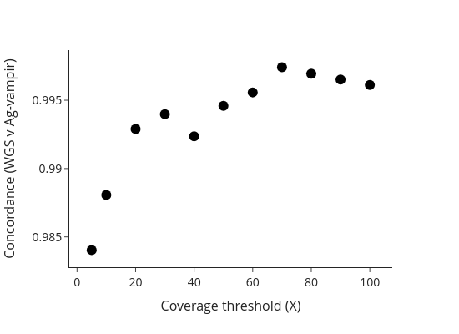
Supplementary Figure 1. Concordance of Ag-vampIR variant calls with whole-genome sequencing (WGS) data. Concordance was evaluated across eleven different minimum read depth thresholds using 40 individuals from Obuasi, Ghana, sequenced to 30X per individual as part of the Ag1000g project. High concordance (>99.3%) was observed at amplicon read depths of 20X and above, demonstrating the reliability of the Ag-vampIR-AmpSeeker platform.

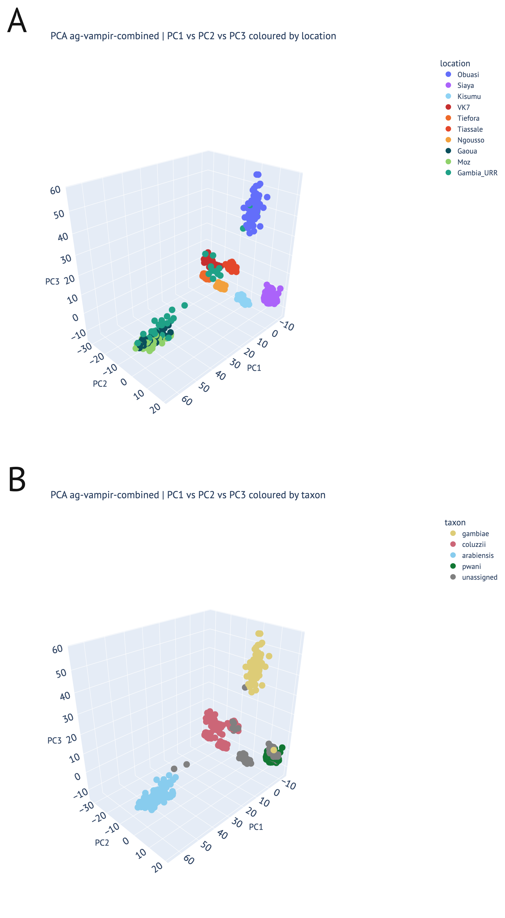
Supplementary Figure 2. Principal components analysis (PCA) of the 784 QC-passed Ag-vampIR samples (PC1-PC3), coloured by (A) cohort and (B) taxon assignment. PCA used all variants present on amplicons after filtering.

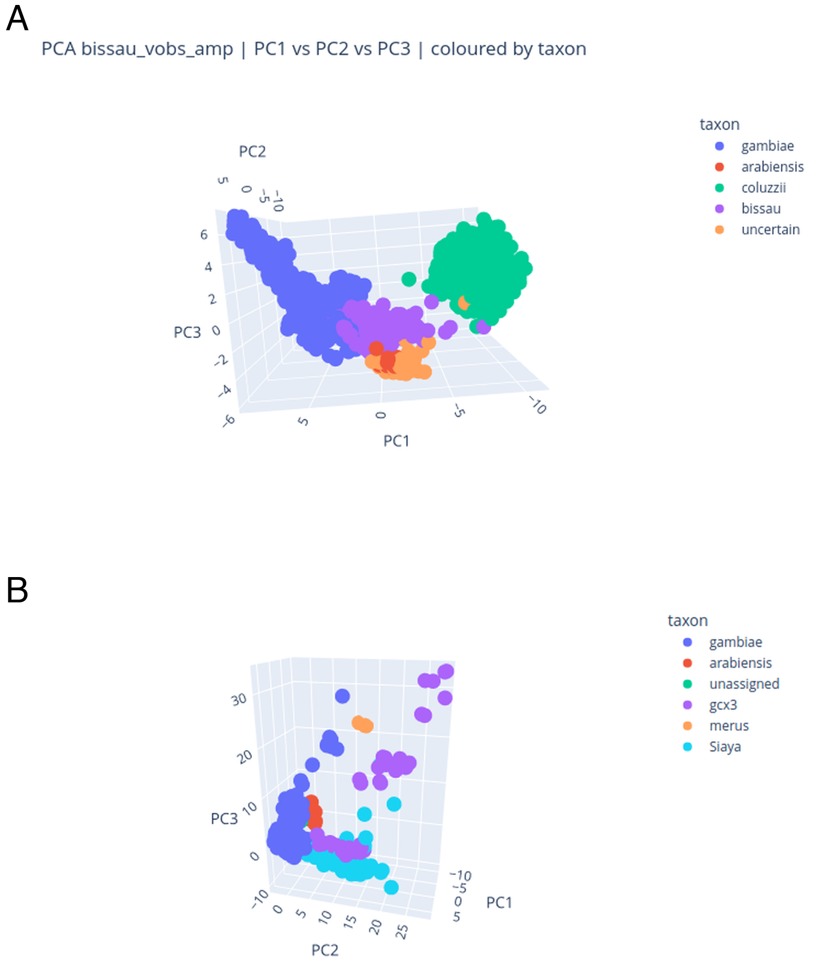
Supplementary Figure 3. 3D principal components analysis (PCA) of whole-genome sequenced Ag1000g mosquitoes together with Ag-vampIR samples from (A) The Gambia and (B) the Siaya colony. PCA was performed using SNPs targeted by the Ag-vampIR panel. In (B), Siaya samples cluster near the An. gambiae cluster and adjacent to the Pwani molecular form (Gcx3), suggesting potential shared ancestry.

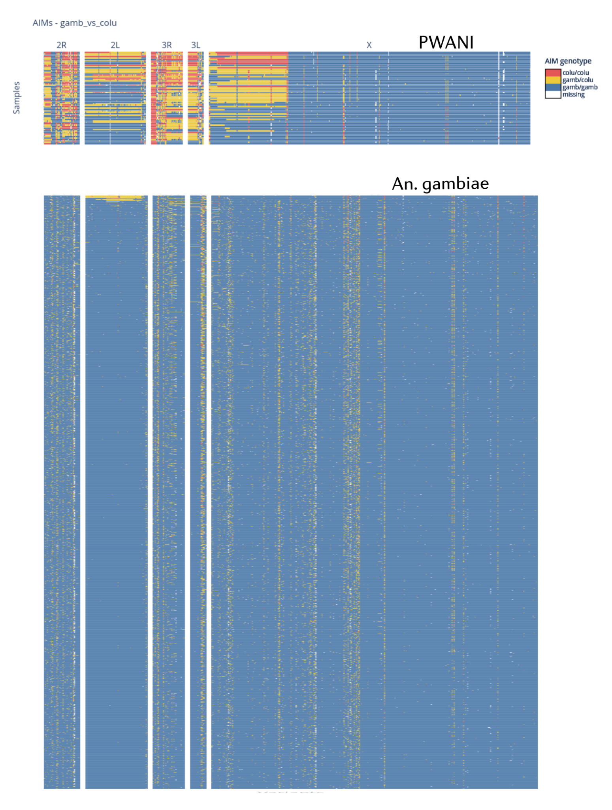
Supplementary Figure 4. Ancestry informative marker (AIM) genotypes for Pwani molecular form (Gcx3) and An. gambiae samples. AIM patterns on autosomes for Pwani samples appear mixed, while An. gambiae samples consistently show An. gambiae-like AIMs, highlighting the distinct ancestry profiles of these taxa.

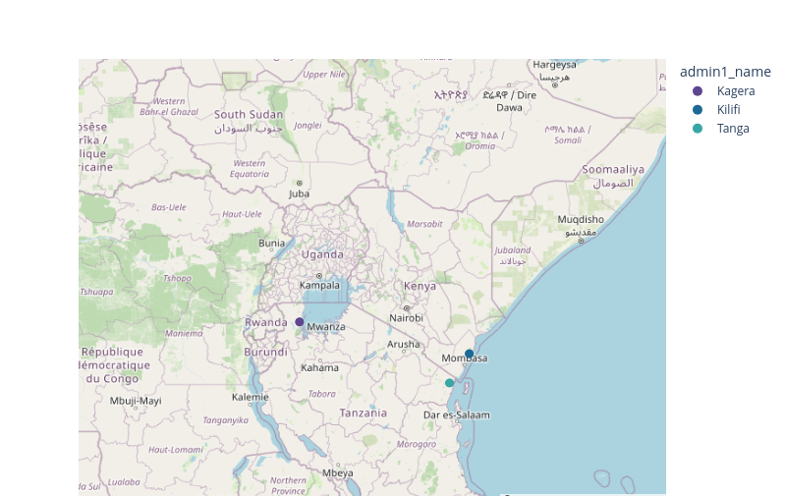
Supplementary Figure 5: Geographic distribution of the Pwani molecular form (Gcx3) in East Africa. A single Pwani individual from the Ag1000g dataset was collected in Muleba, Tanzania, on the western coast of Lake Victoria in 2015, suggesting that this taxon may also exist in inland areas.

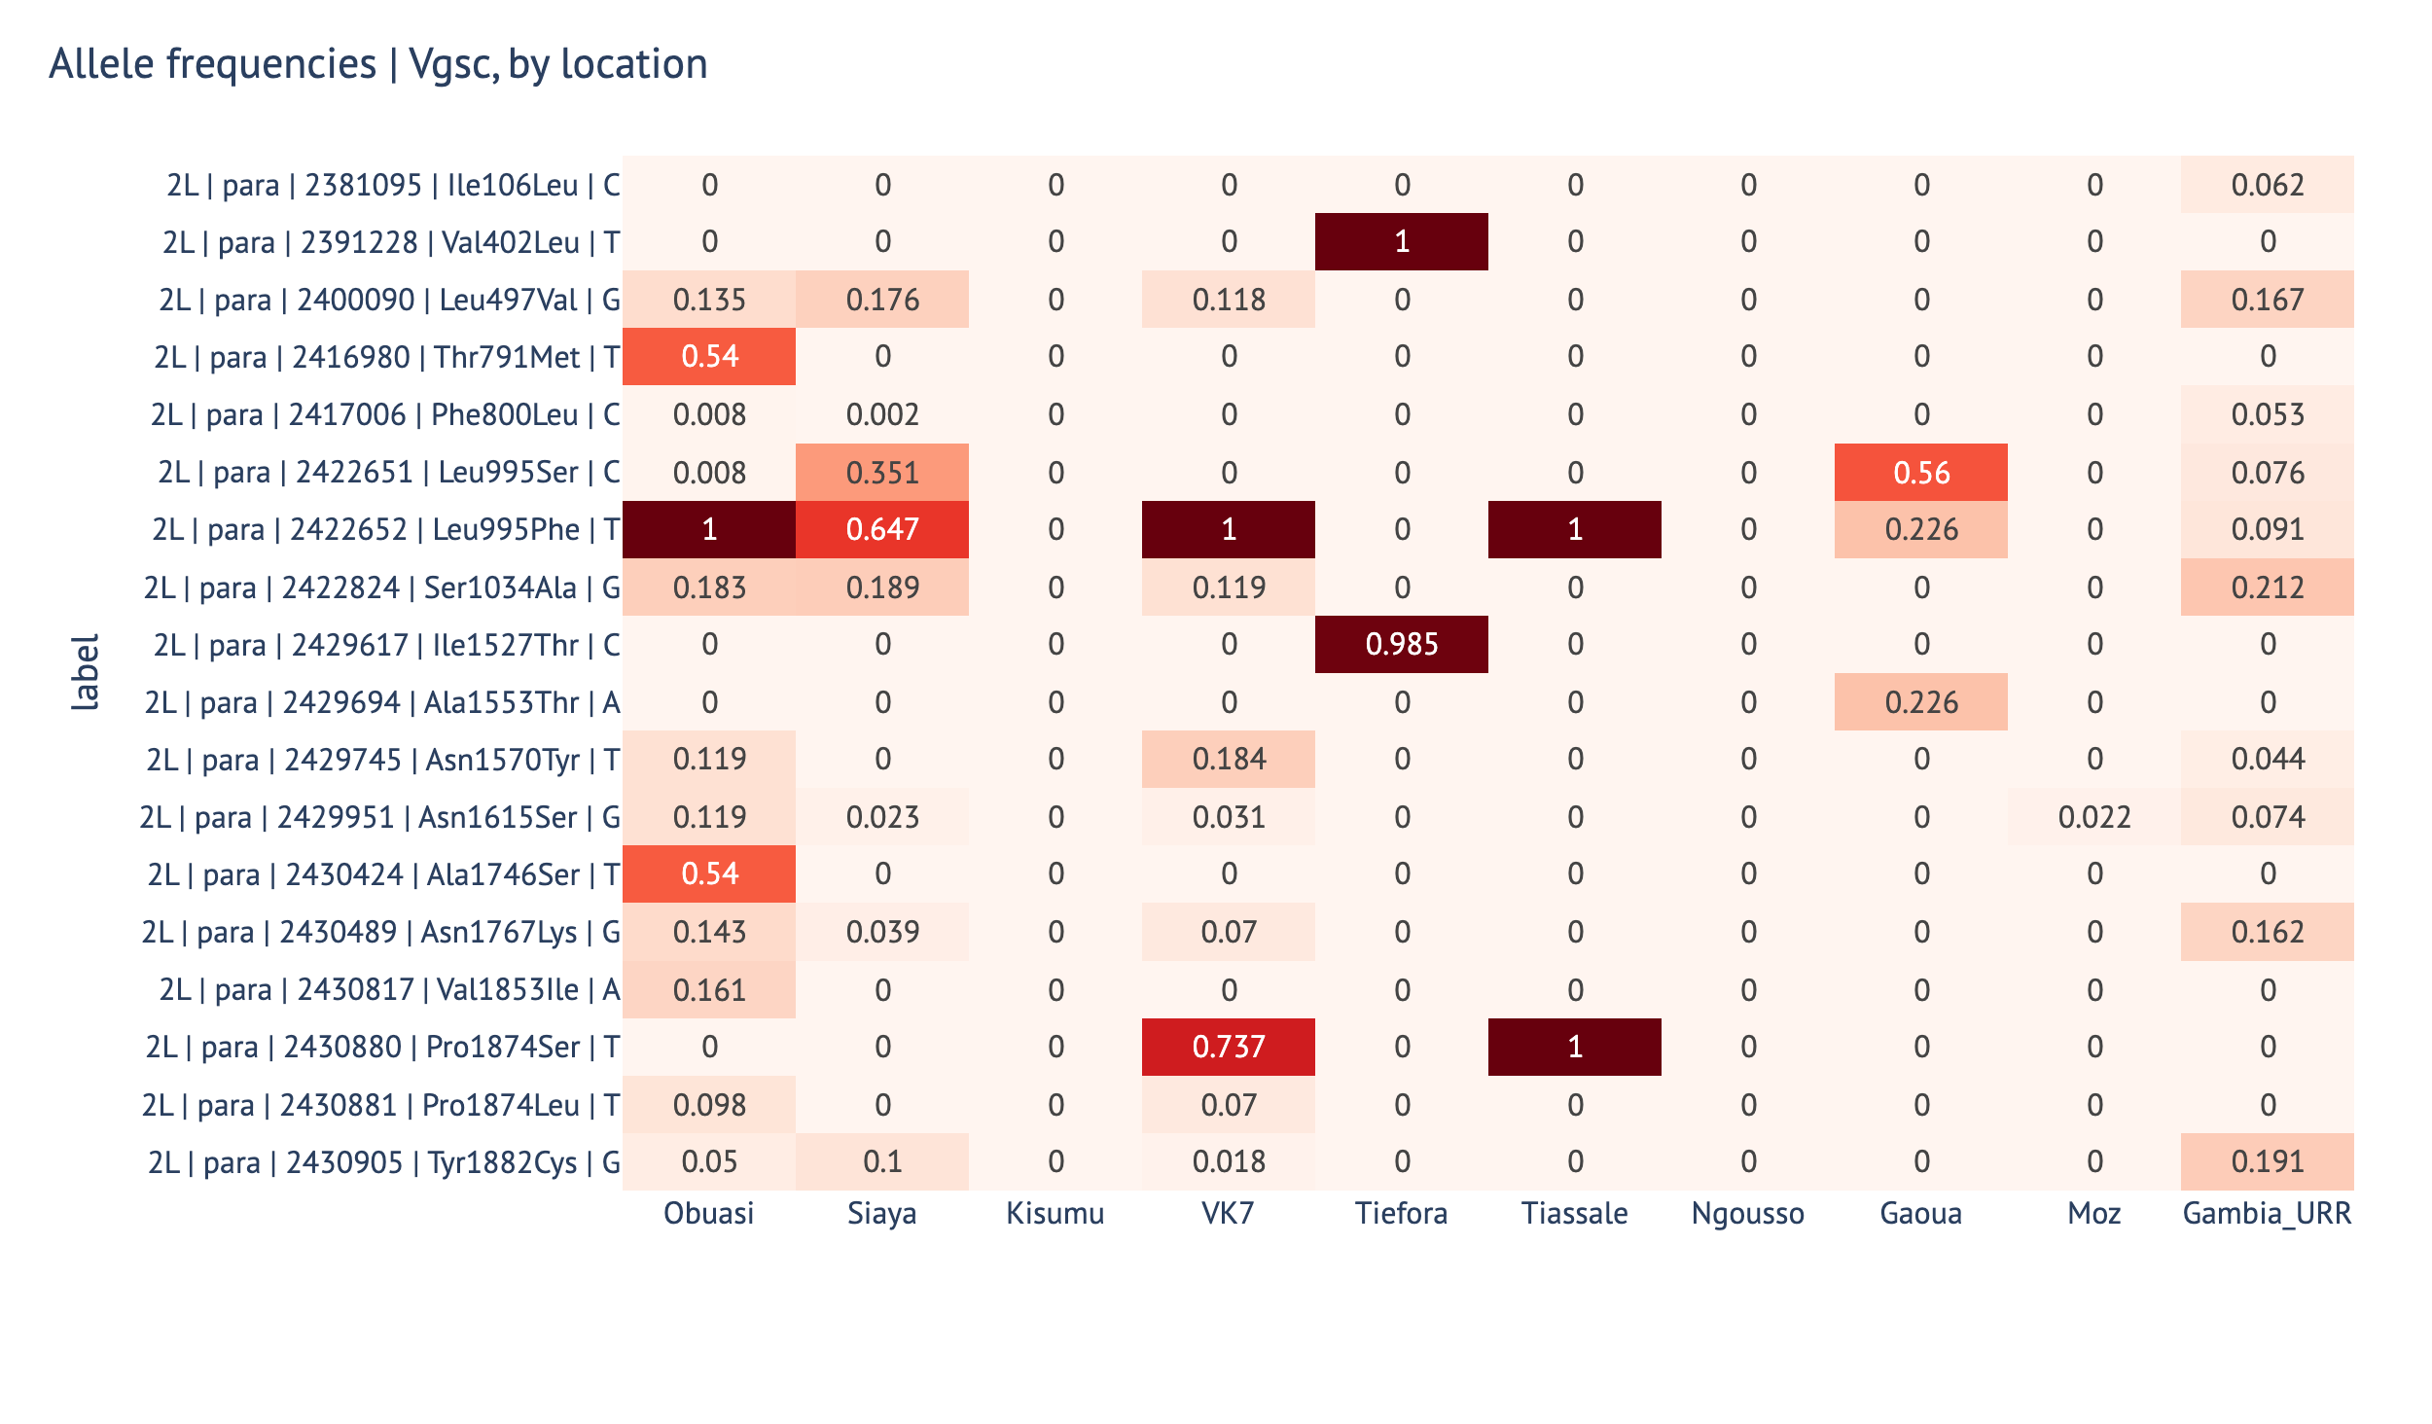
Supplementary Figure 6. Allele frequencies of known resistance-associated SNPs in the Voltage-gated sodium channel (Vgsc) in each cohort. Frequencies were calculated using SNPs on Vgsc amplicons, and tagging SNPs were used to infer kdr haplotypes (Supplementary Table 3).

